DAY 3

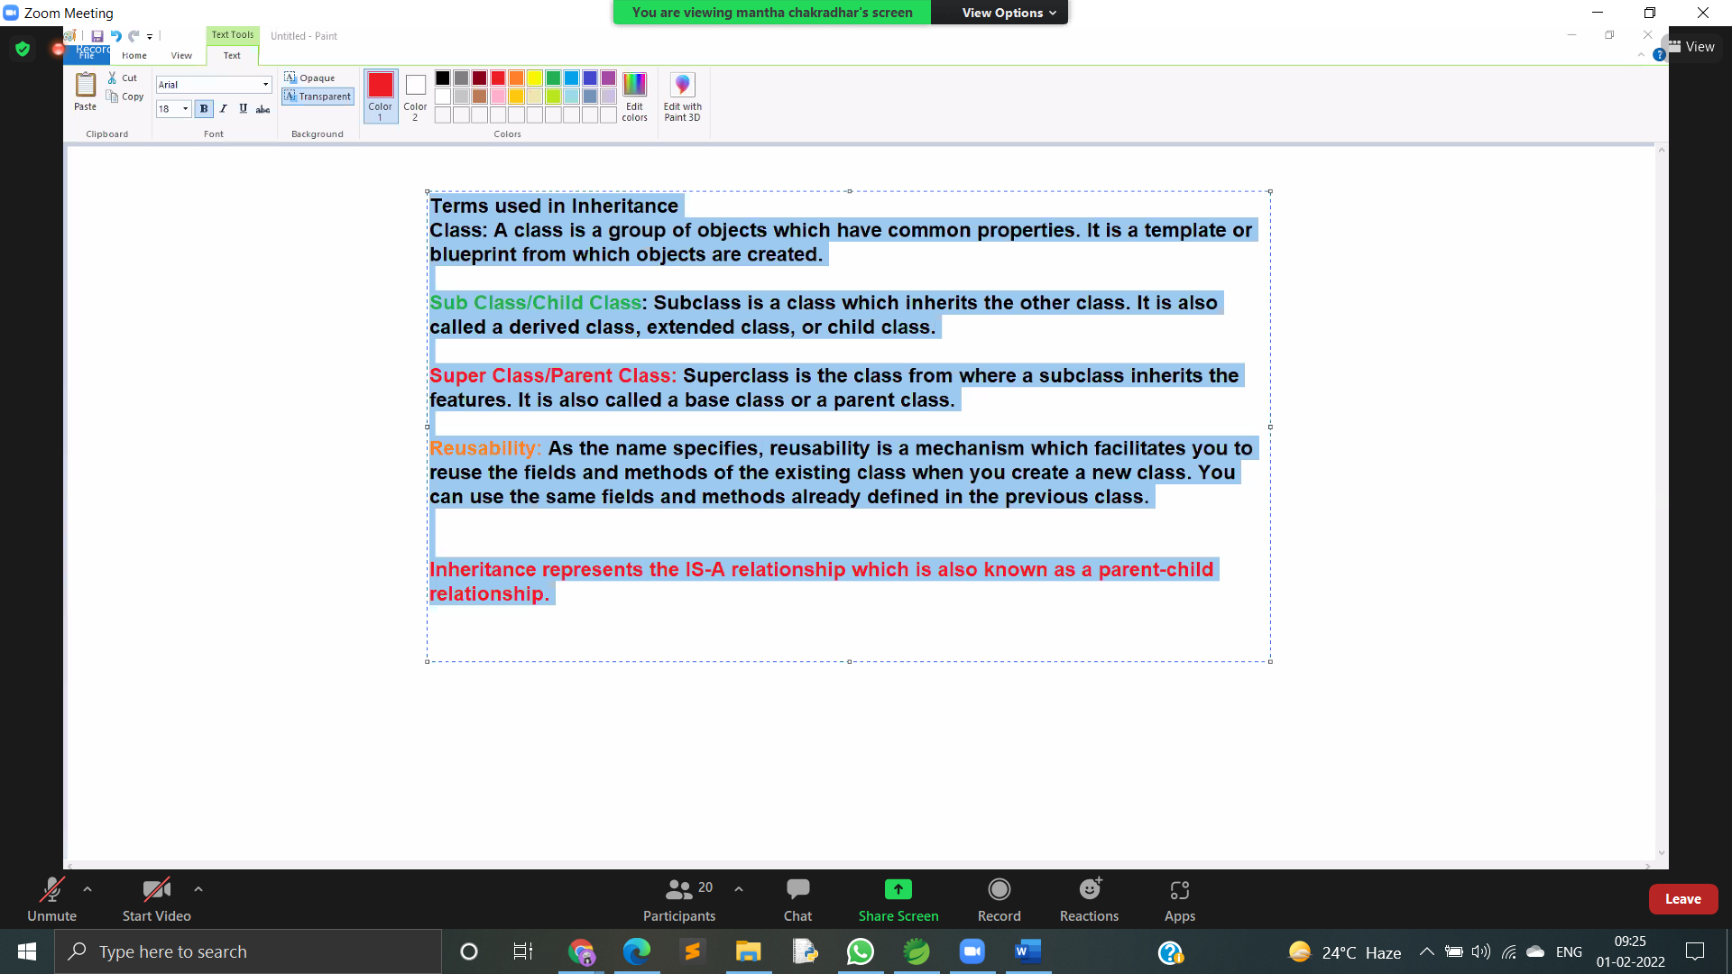

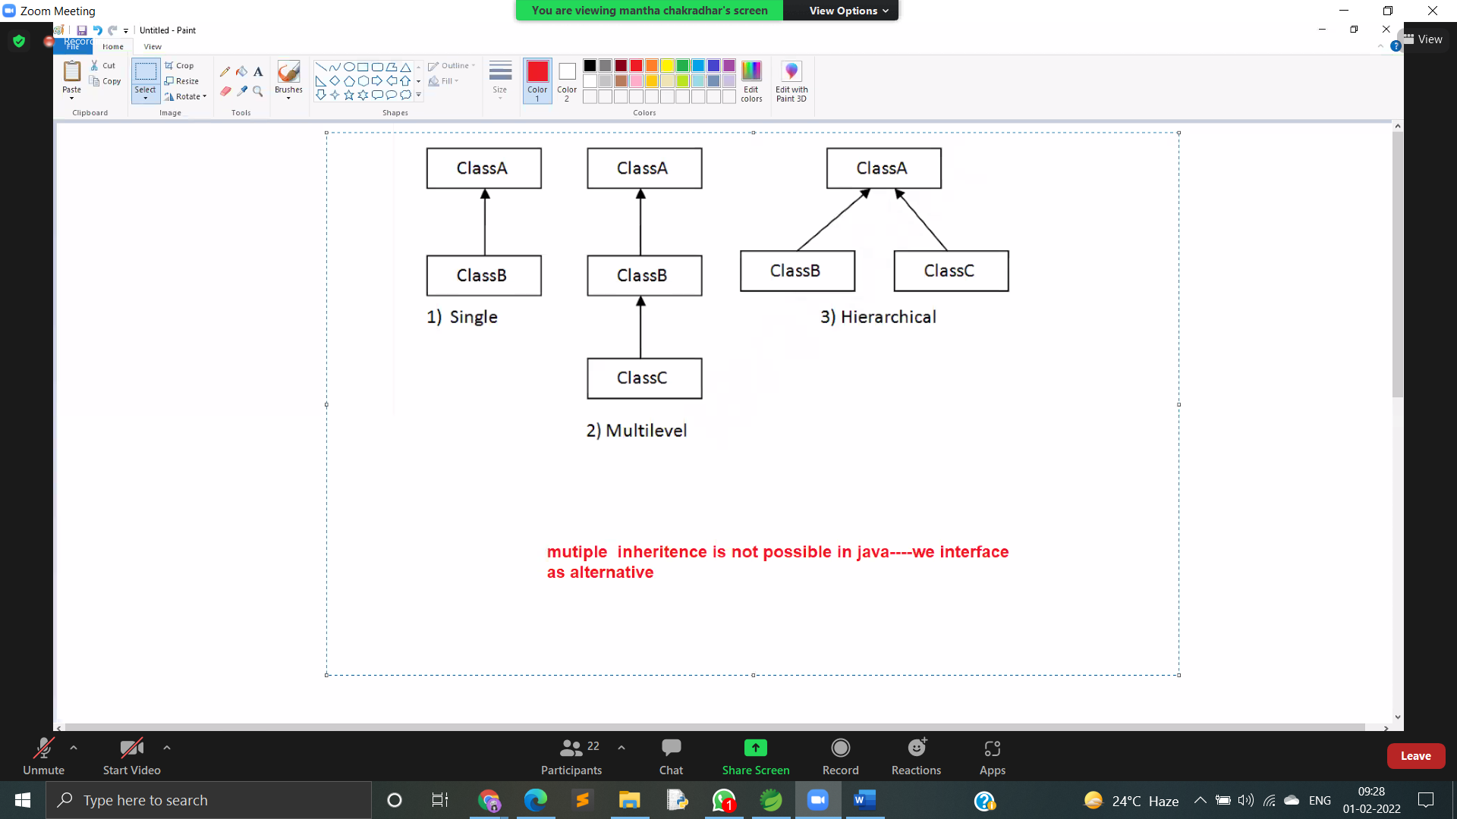

<https://www.geeksforgeeks.org/what-is-has-a-relation-in-java/>

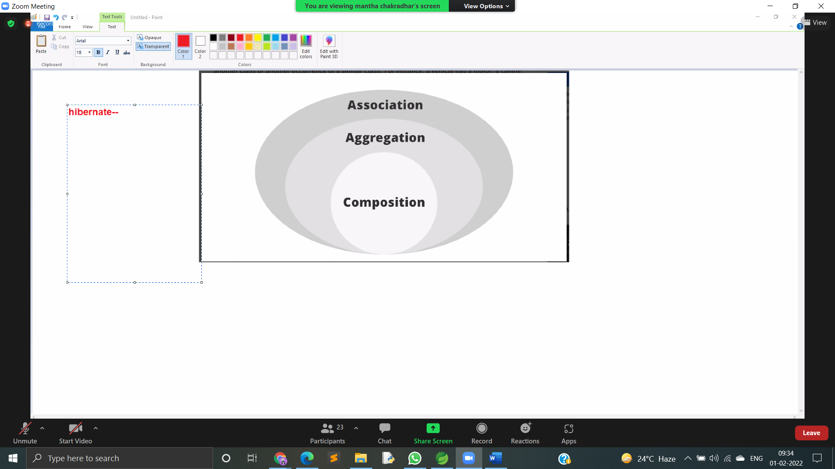

Is a relation ship

Has a relation ship

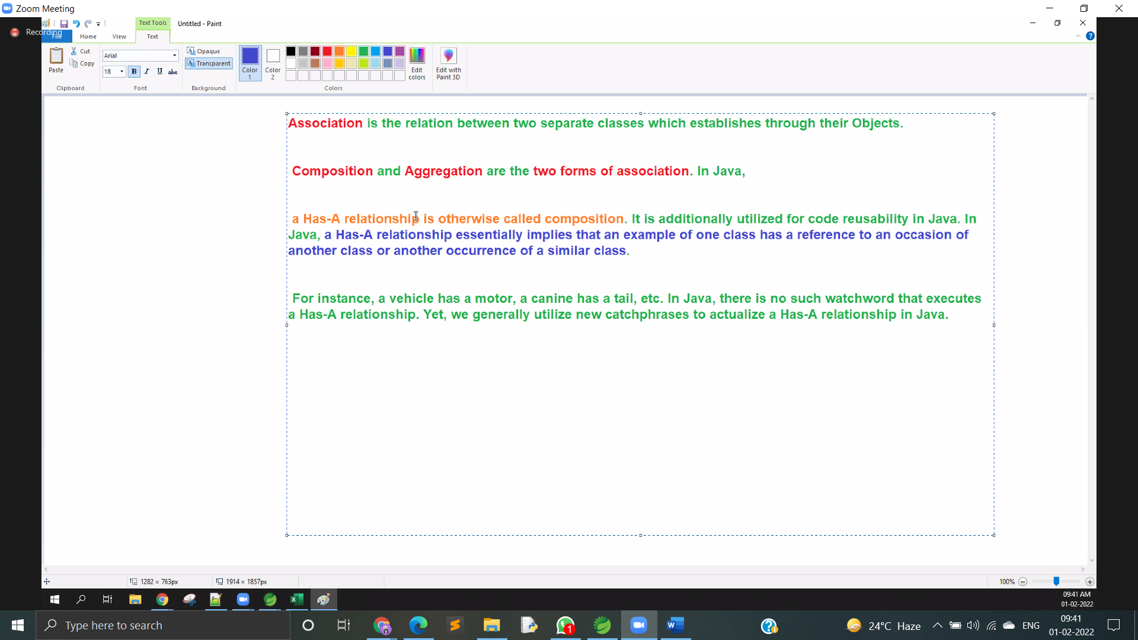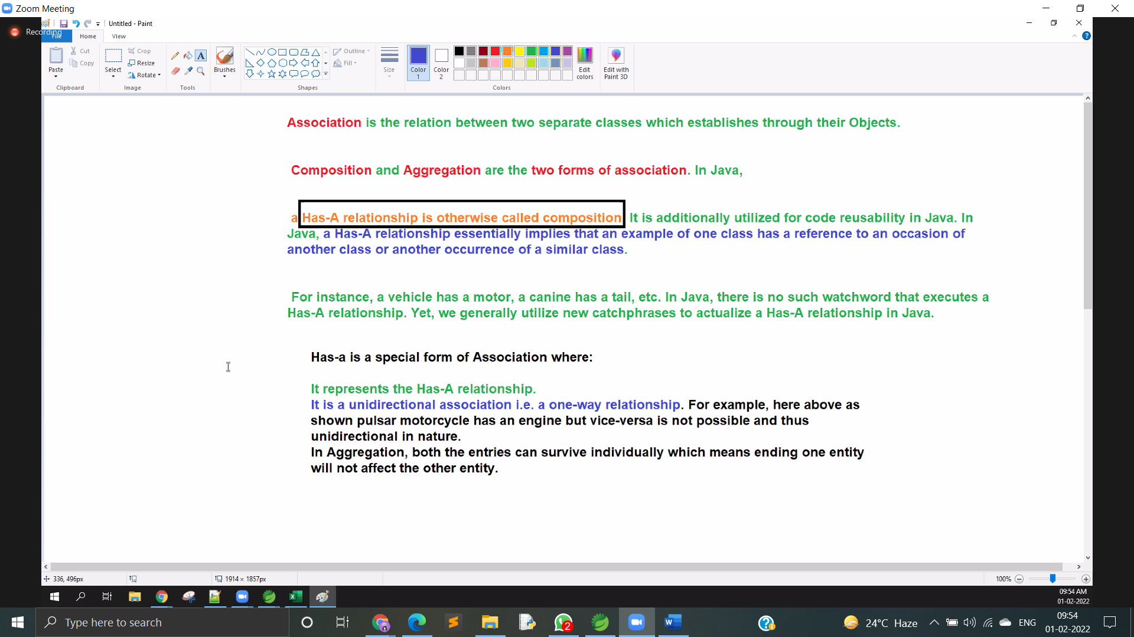

HAS a relationship example

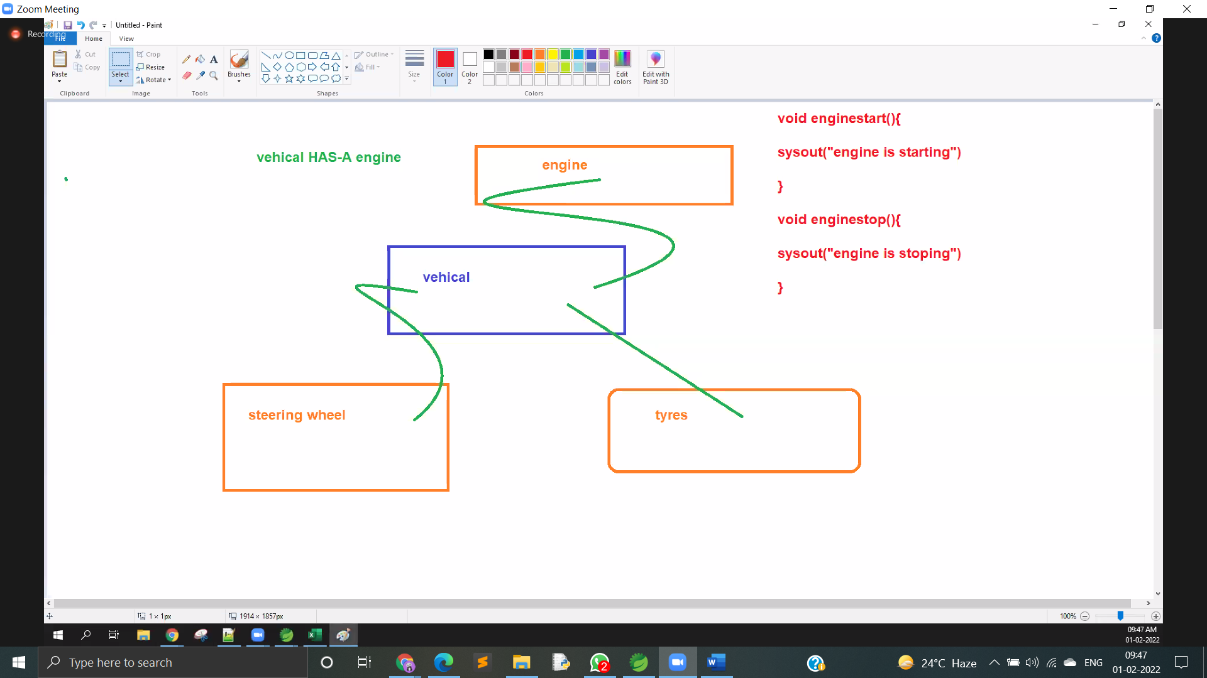

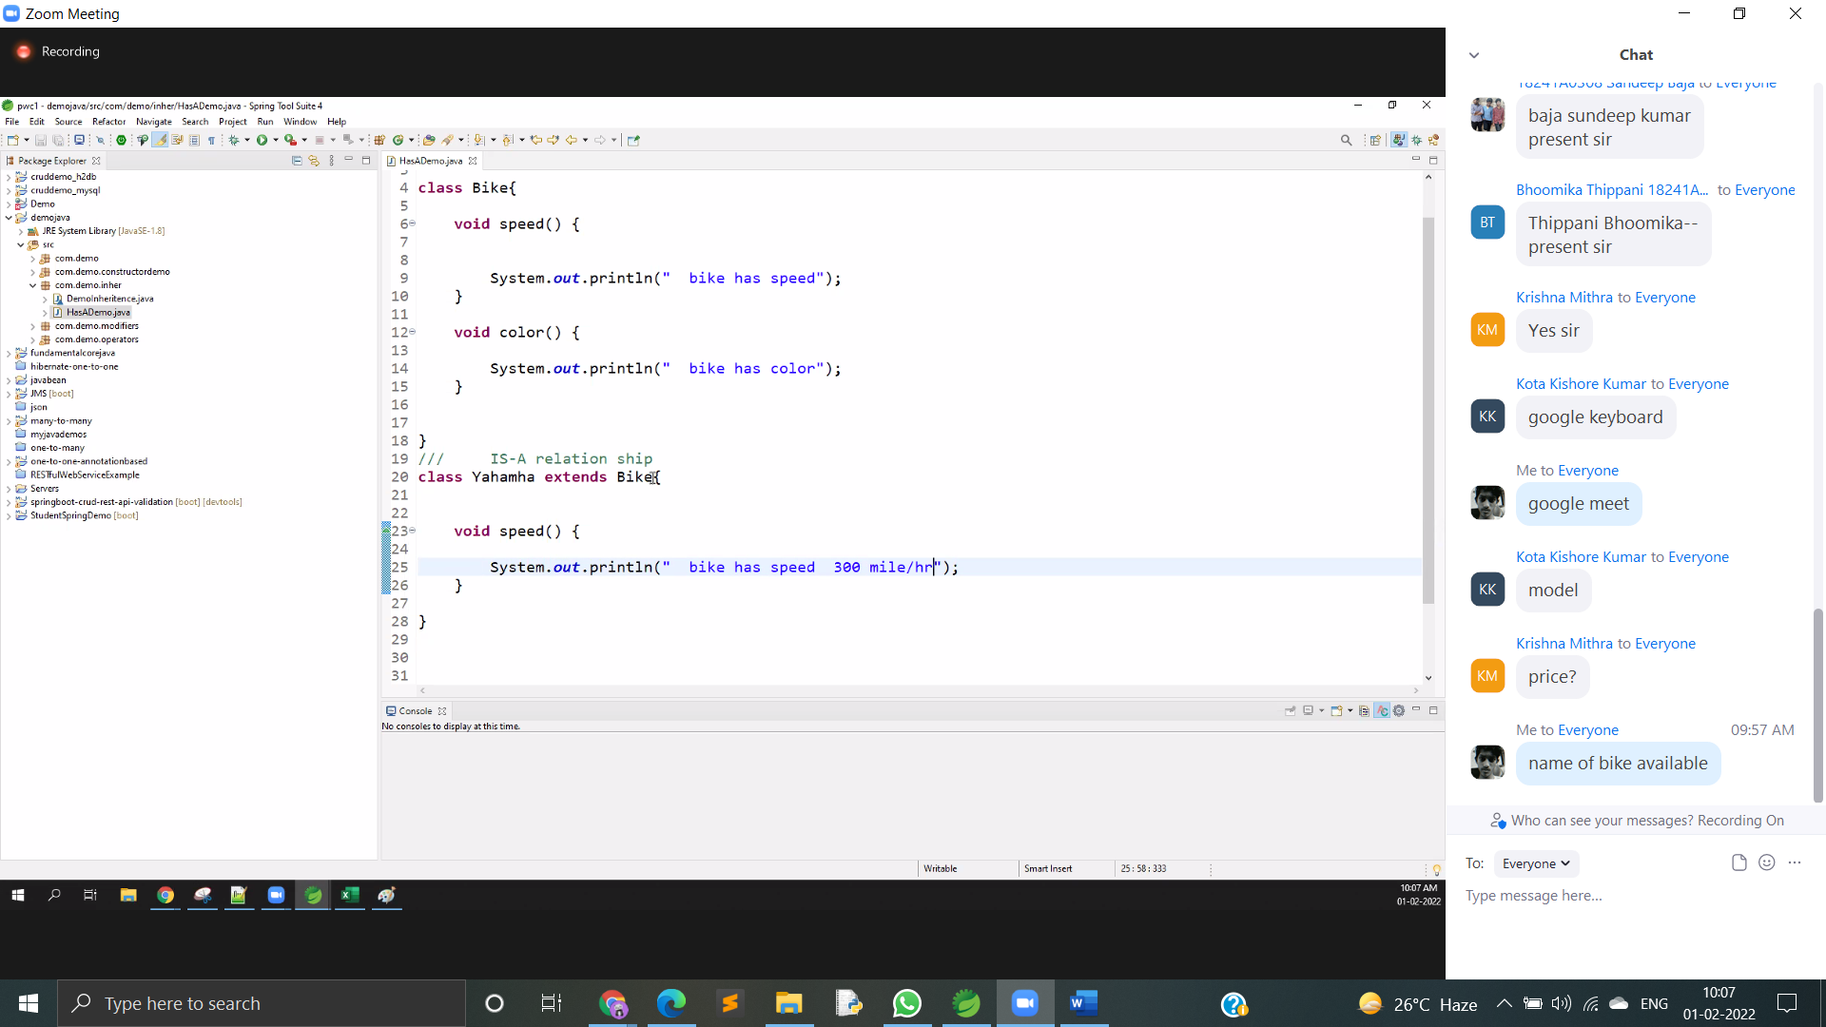

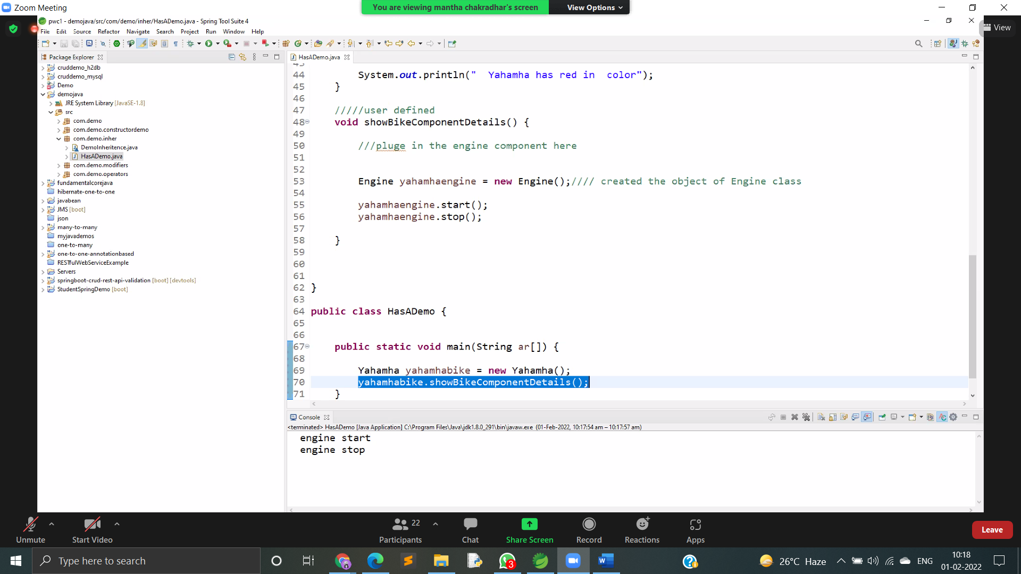

Code of above prg

package com.demo.inher;/// this is an another componentclass Engine { void start() { System.out.println(" engine start"); } void stop() { System.out.println(" engine stop"); }}class Bike { void speed() { System.out.println(" bike has speed"); } void color() { System.out.println(" bike has color"); }}/// IS-A relation shipclass Yahamha extends Bike { void speed() { System.out.println(" bike has speed 300 mile/hr"); } void color() { System.out.println(" Yahamha has red in color"); } /////user defined void showBikeComponentDetails() { ///pluge in the engine component here Engine yahamhaengine = new Engine();//// created the object of Engine class and referenced here yahamhaengine.start();

yahamhaengine.stop();

}

}

public class HasADemo {

public static void main(String ar[]) {

Yahamha yahamhabike = new Yahamha();

yahamhabike.showBikeComponentDetails();

}

}

LINK

<https://www.geeksforgeeks.org/what-is-has-a-relation-in-java/>

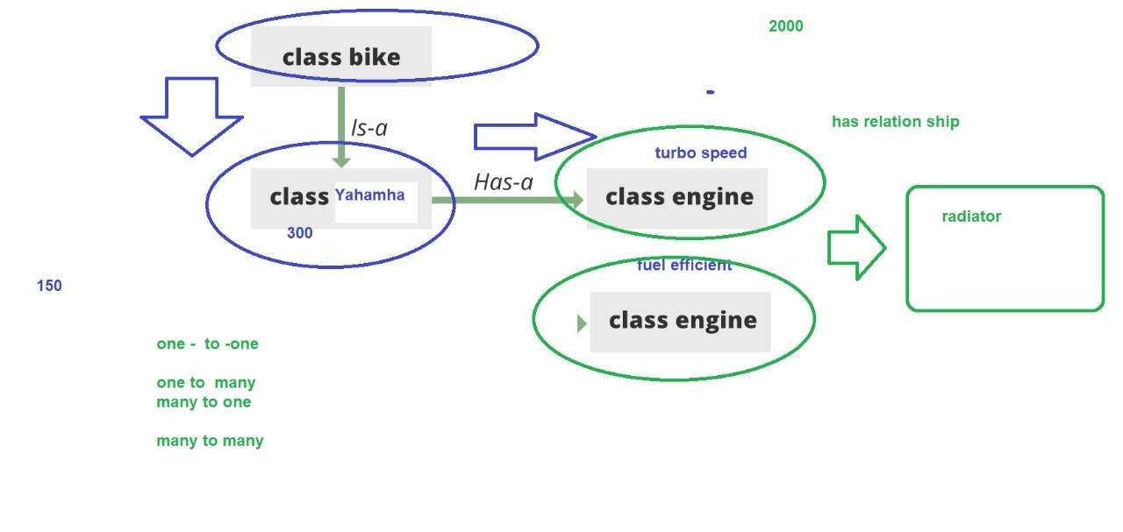

ABSTRACT

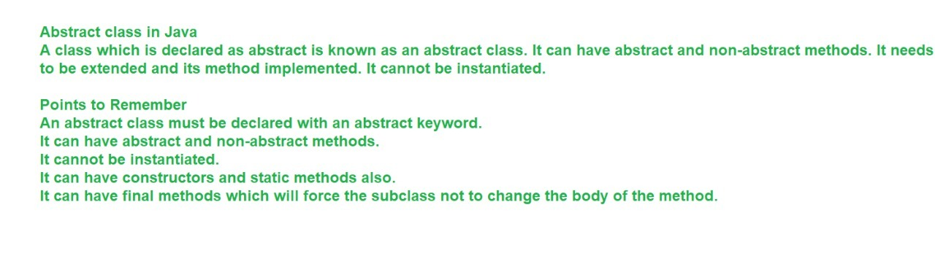

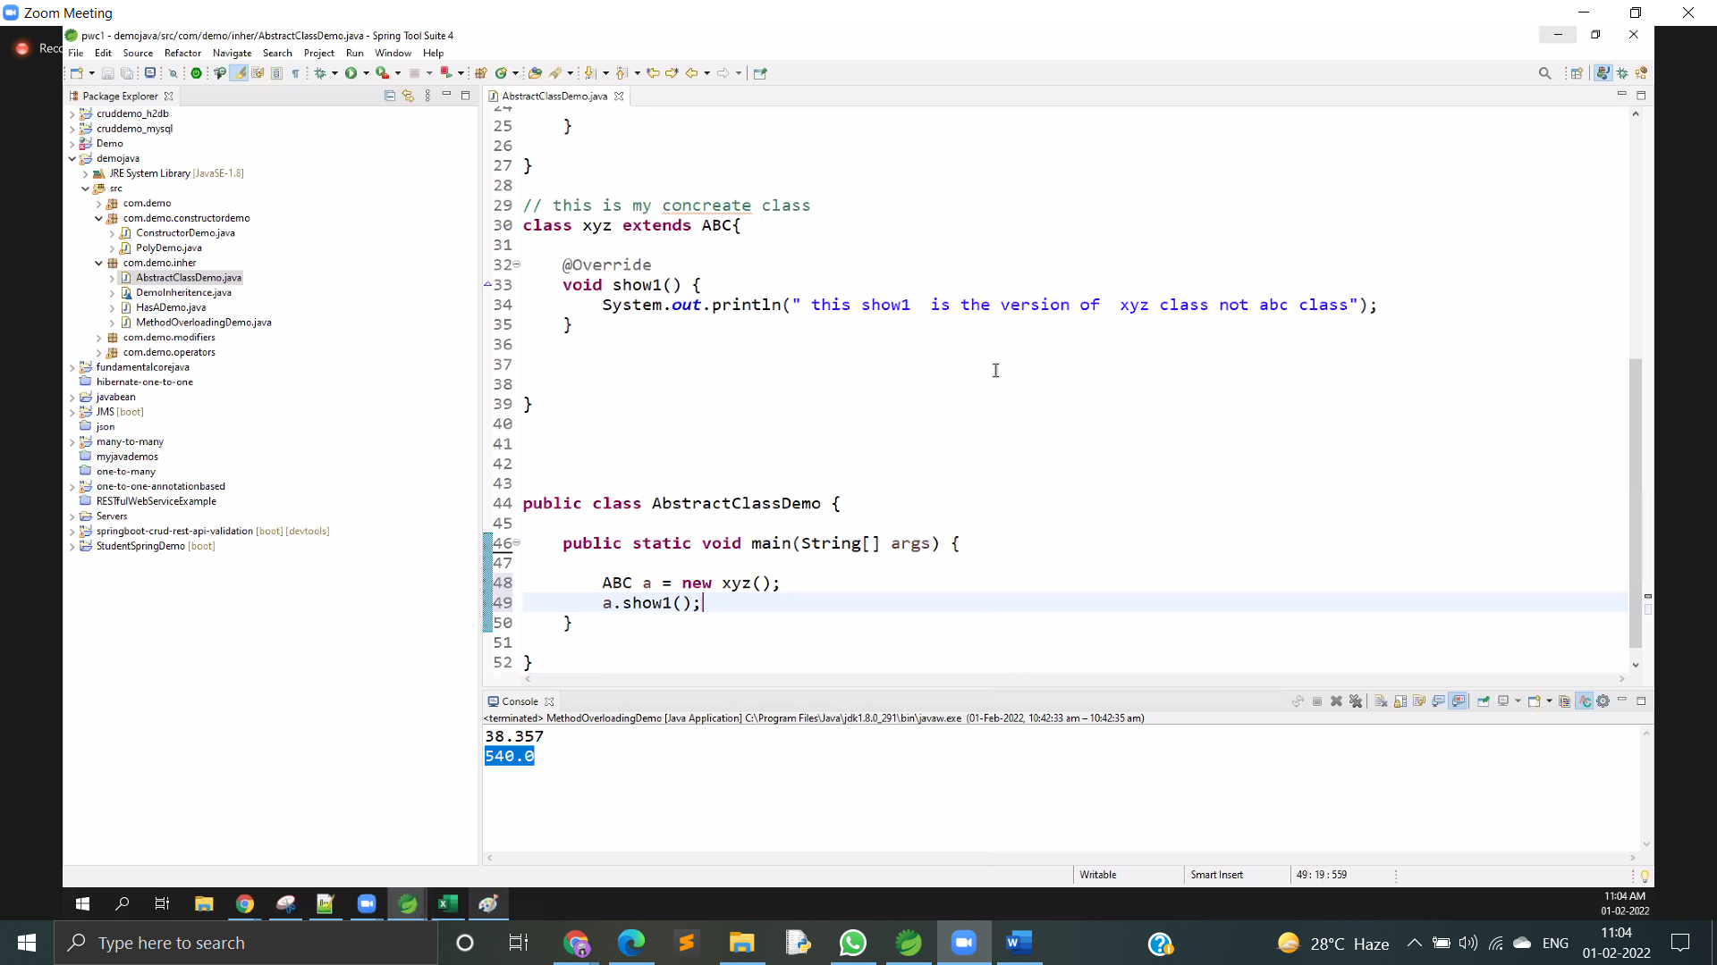

package com.demo.inher;

abstract class ABC {

// contructor

ABC() {

}

// non abstract method

void show() {

System.out.println(" this show abc class");

}

// non abstract method

abstract void show1();

//static methods

static void show3() {

}

}

// this is my concreate class

class xyz extends ABC{

//overrid is happening here

void show1() {

System.out.println(" this show1 is the version of xyz class not abc class");

}

}

public class AbstractClassDemo {

public static void main(String[] args) {

ABC a = new xyz();

a.show1();

}

INTERFACE

Are nothing but contracts.

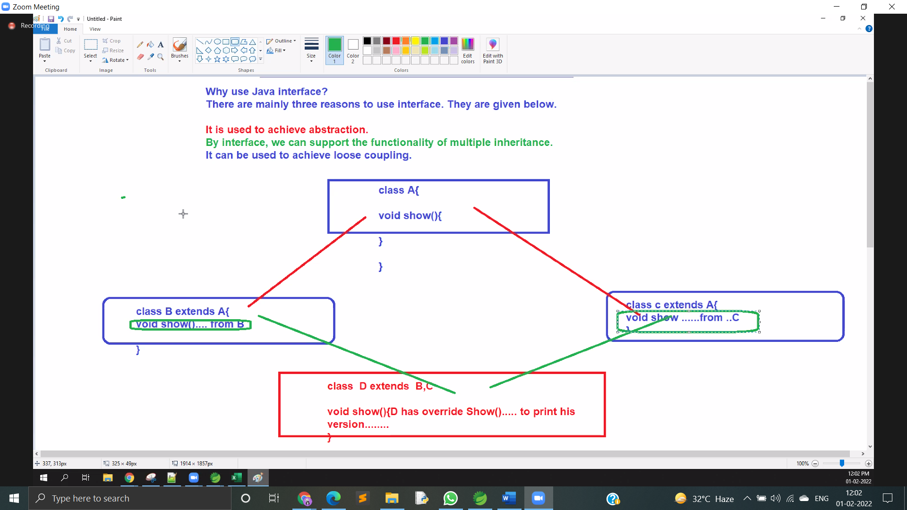

package com.demo.inher;interface Car { void speed(); void brake(); void Lights();}class LuxuryCar implements Car { @Override public void speed() { System.out.println(" 300 km/hr"); } @Override public void brake() { System.out.println(" disk brake"); } @Override public void Lights() { System.out.println(" high visioned lights"); }}class CheapCar implements Car { @Override public void speed() { System.out.println(" 100 km/hr"); } @Override public void brake() { System.out.println(" disk not brake"); } @Override public void Lights() { System.out.println(" low visioned lights"); }}public class InterfaceDemo { public static void main(String ar[]) { LuxuryCar l = new LuxuryCar(); l.brake(); CheapCar c = new CheapCar();

c.brake();

}

}

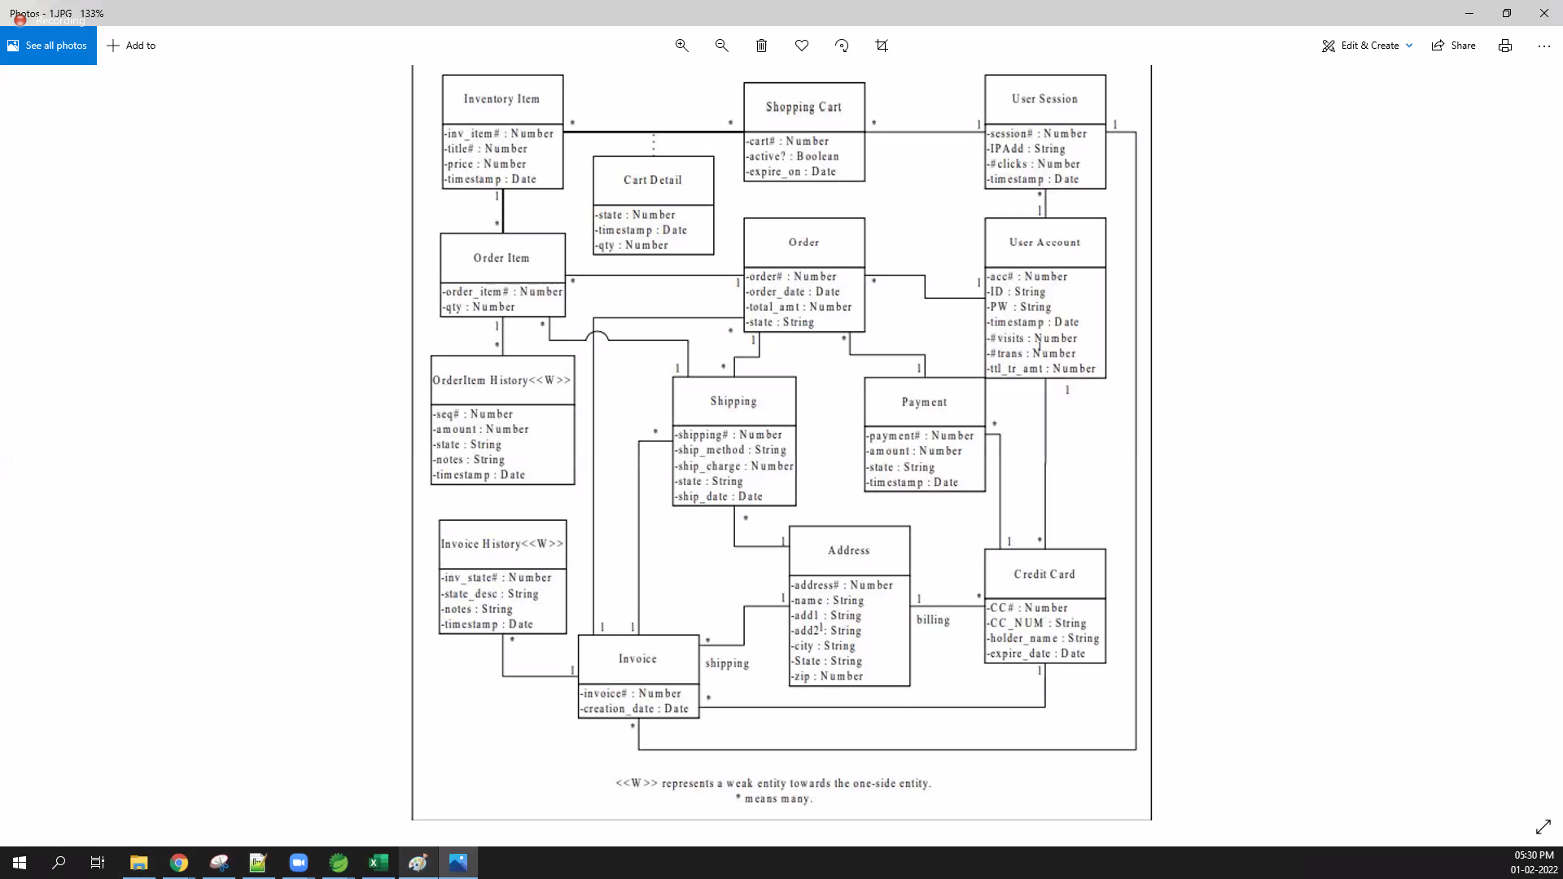

DAY 4

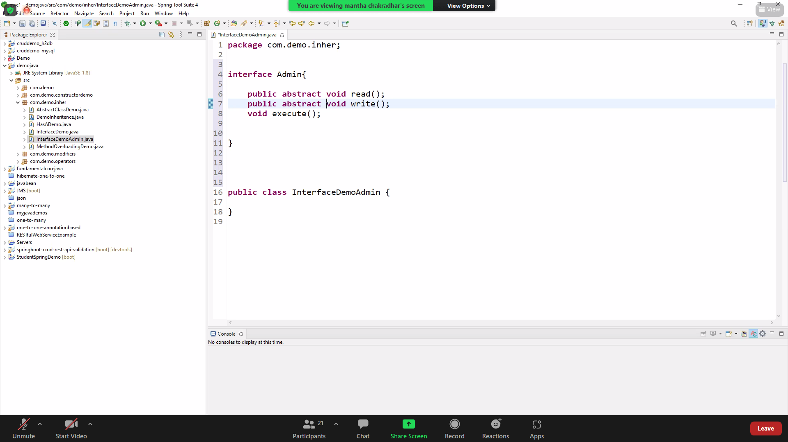

Abstract means we have to write the method after wards.

INTERFACE

/\*

\*

\* However, an interface is different from a class in several ways, including −

You cannot instantiate an interface.

An interface does not contain any constructors.

All of the methods in an interface are abstract.

An interface cannot contain instance fields.

The only fields that can appear in an interface must be declared both static and final.

An interface is not extended by a class; it is implemented by a class.

An interface can extend multiple interfaces.

\*

\*

\*

\* \*/

interface Admin {

public abstract void read();

public abstract String write(int flag);

double execute(double flag1, double flag2);

}

interface Admin2 {

public abstract void read();

}

class KishoreSubAdim implements Admin2 {

@Override

public void read() {

// TODO Auto-generated method stub

}

}

class RohitSubAdmin implements Admin {

@Override

public void read() {

// TODO Auto-generated method stub

}

@Override

public String write(int flag) {

if (flag == 1) {

System.out.println(" this is rohit");

} else {

System.out.println(" this is not rohit");

}

return null;

}

@Override

public double execute(double flag1, double flag2) {

// TODO Auto-generated method stub

return 0;

}

}

public class InterfaceDemoAdmin {

public static void main(String ar[]) {

RohitSubAdmin subadmin = new RohitSubAdmin();

subadmin.write(3);

}

}

Abstract

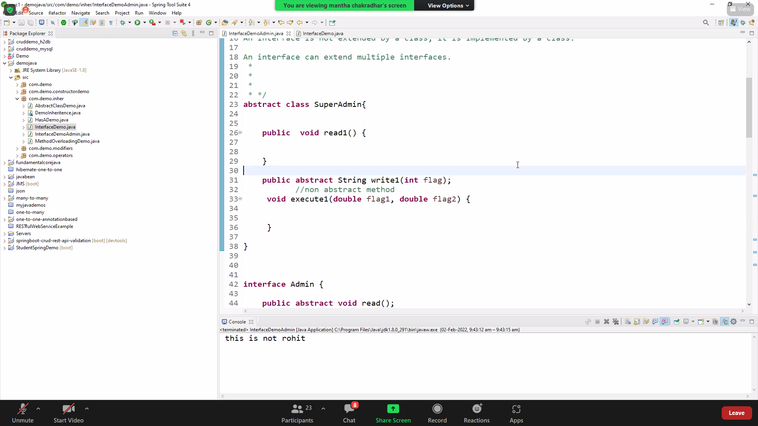

STATIC METHODS

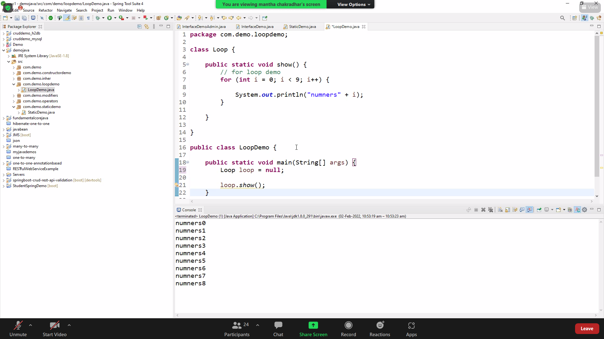

Exception handelling

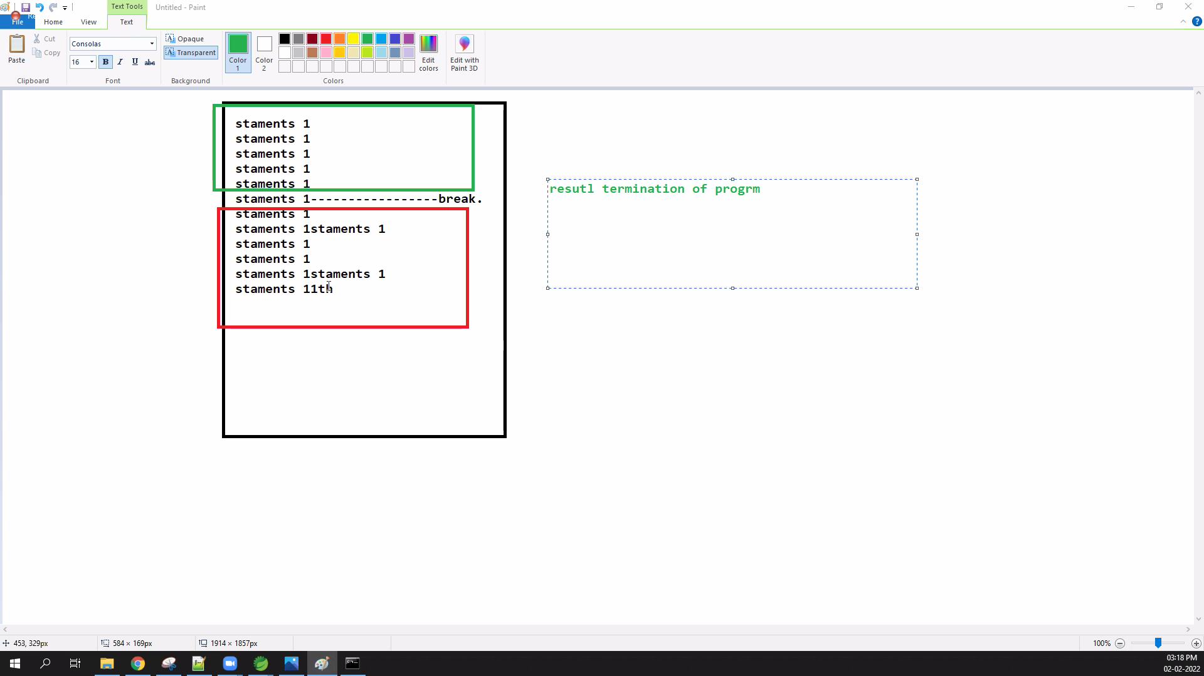

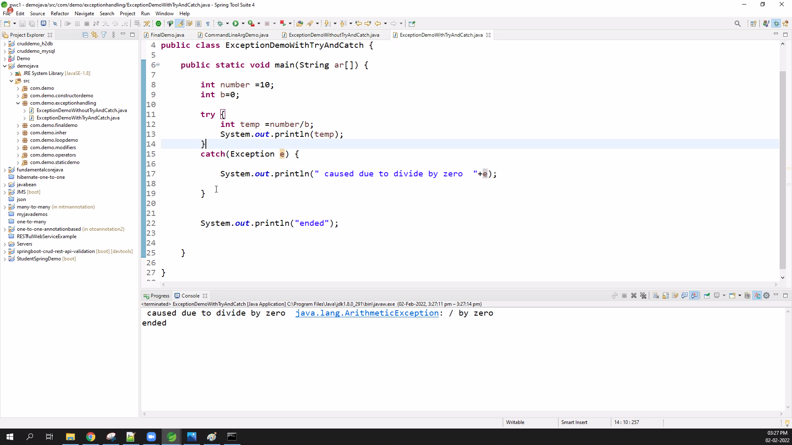

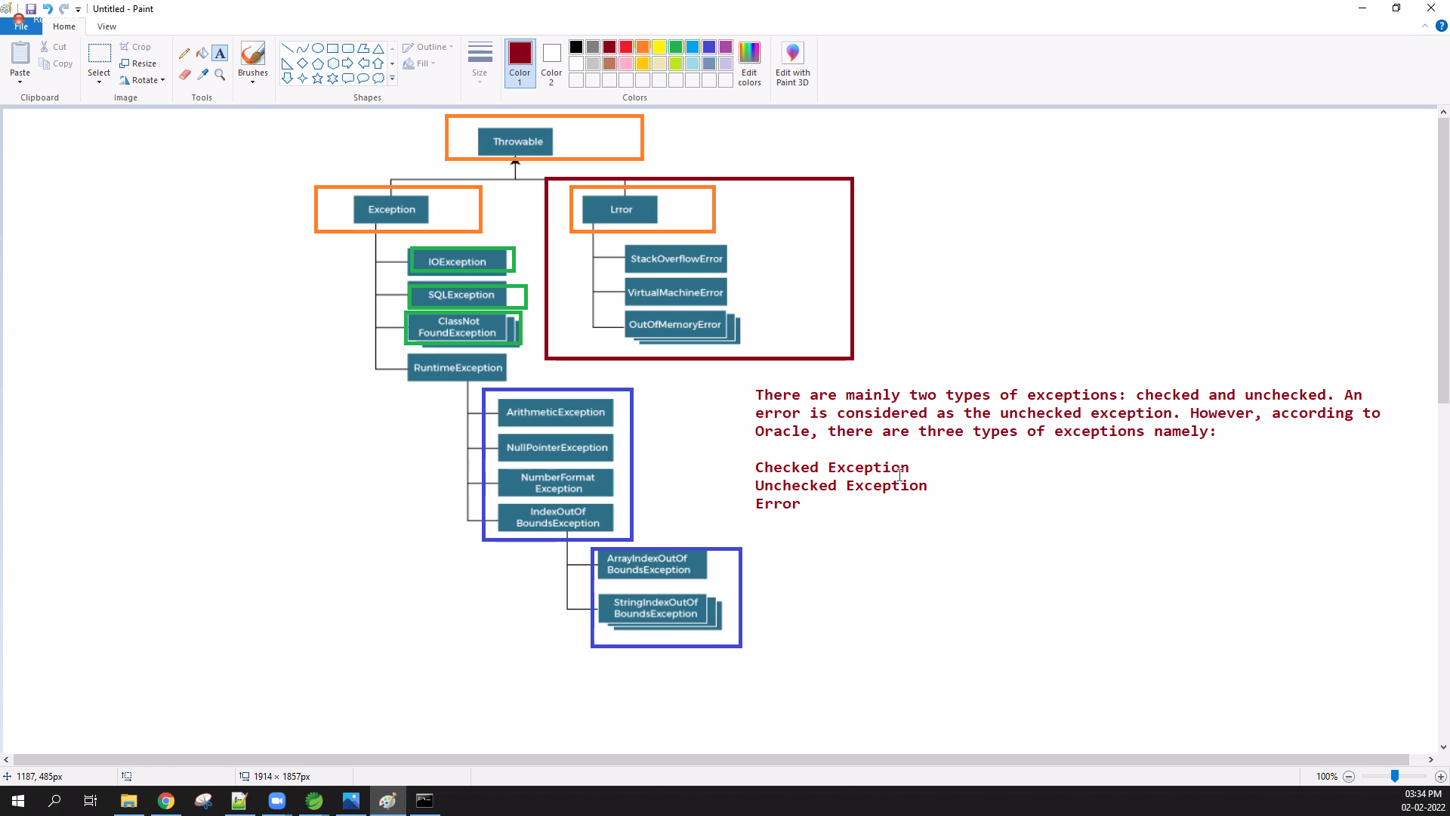

Trype are

Check

Uncheck

<https://www.javatpoint.com/exception-handling-in-java>

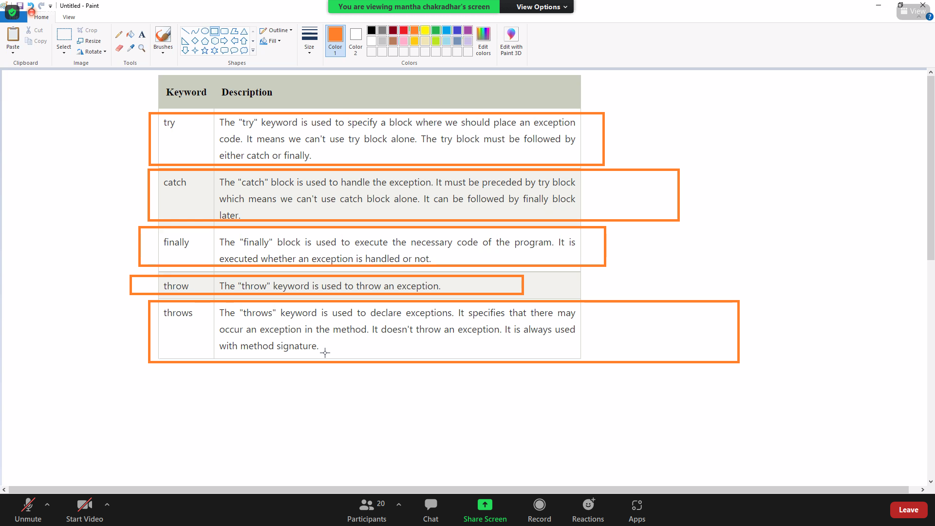

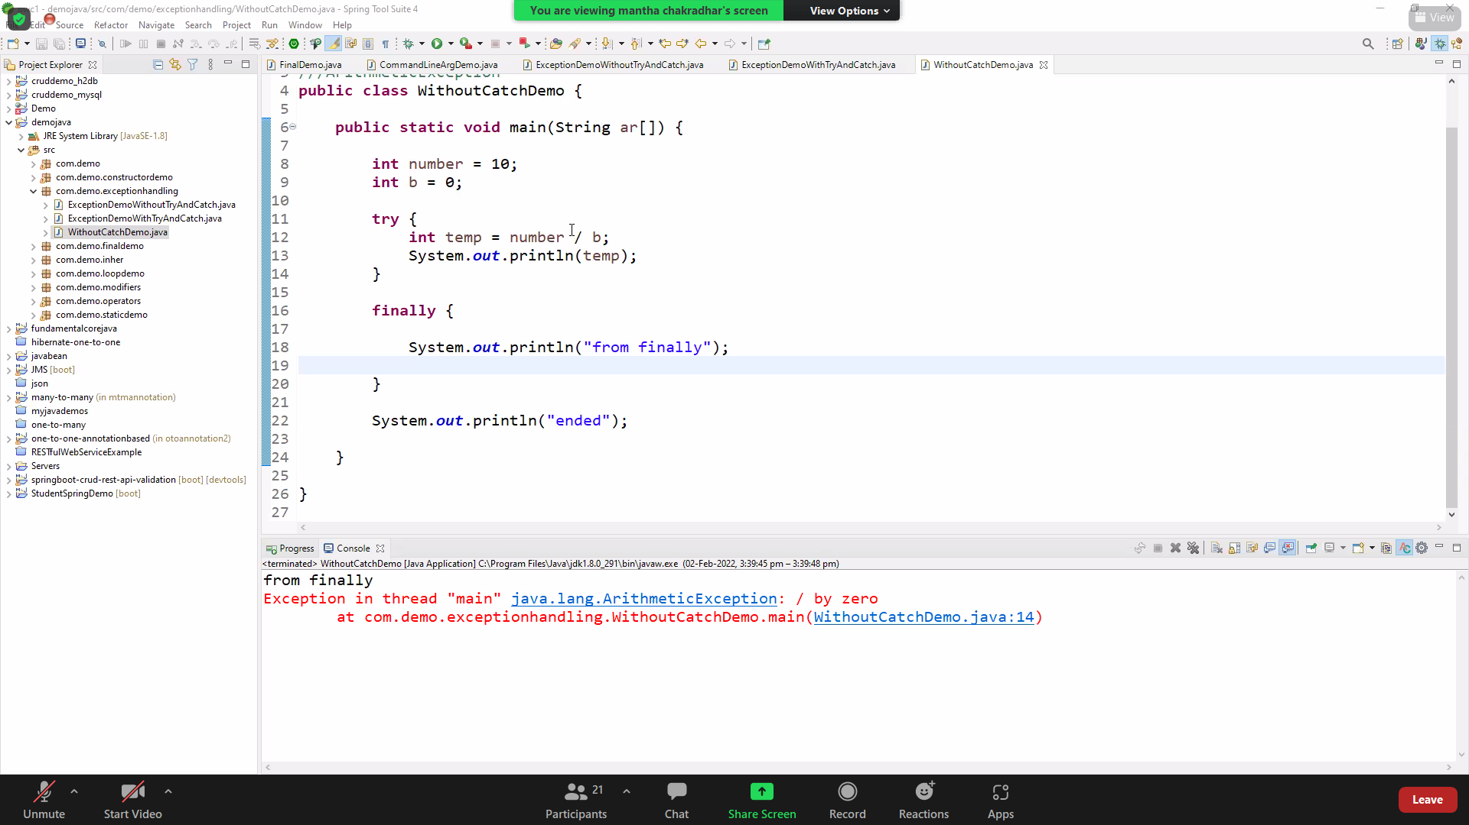

<https://www.geeksforgeeks.org/types-of-exception-in-java-with-examples/>

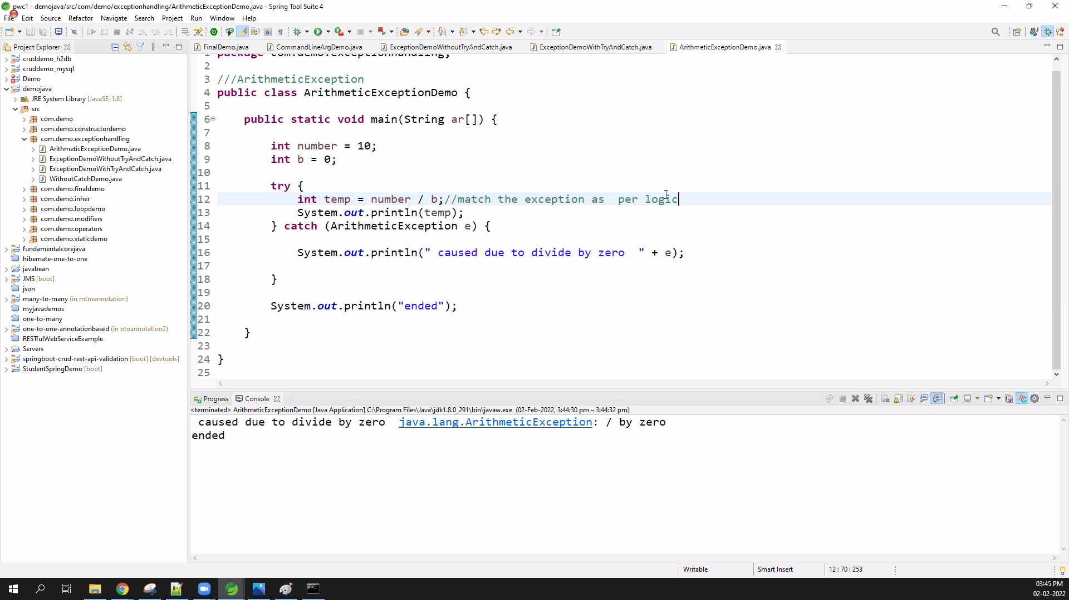

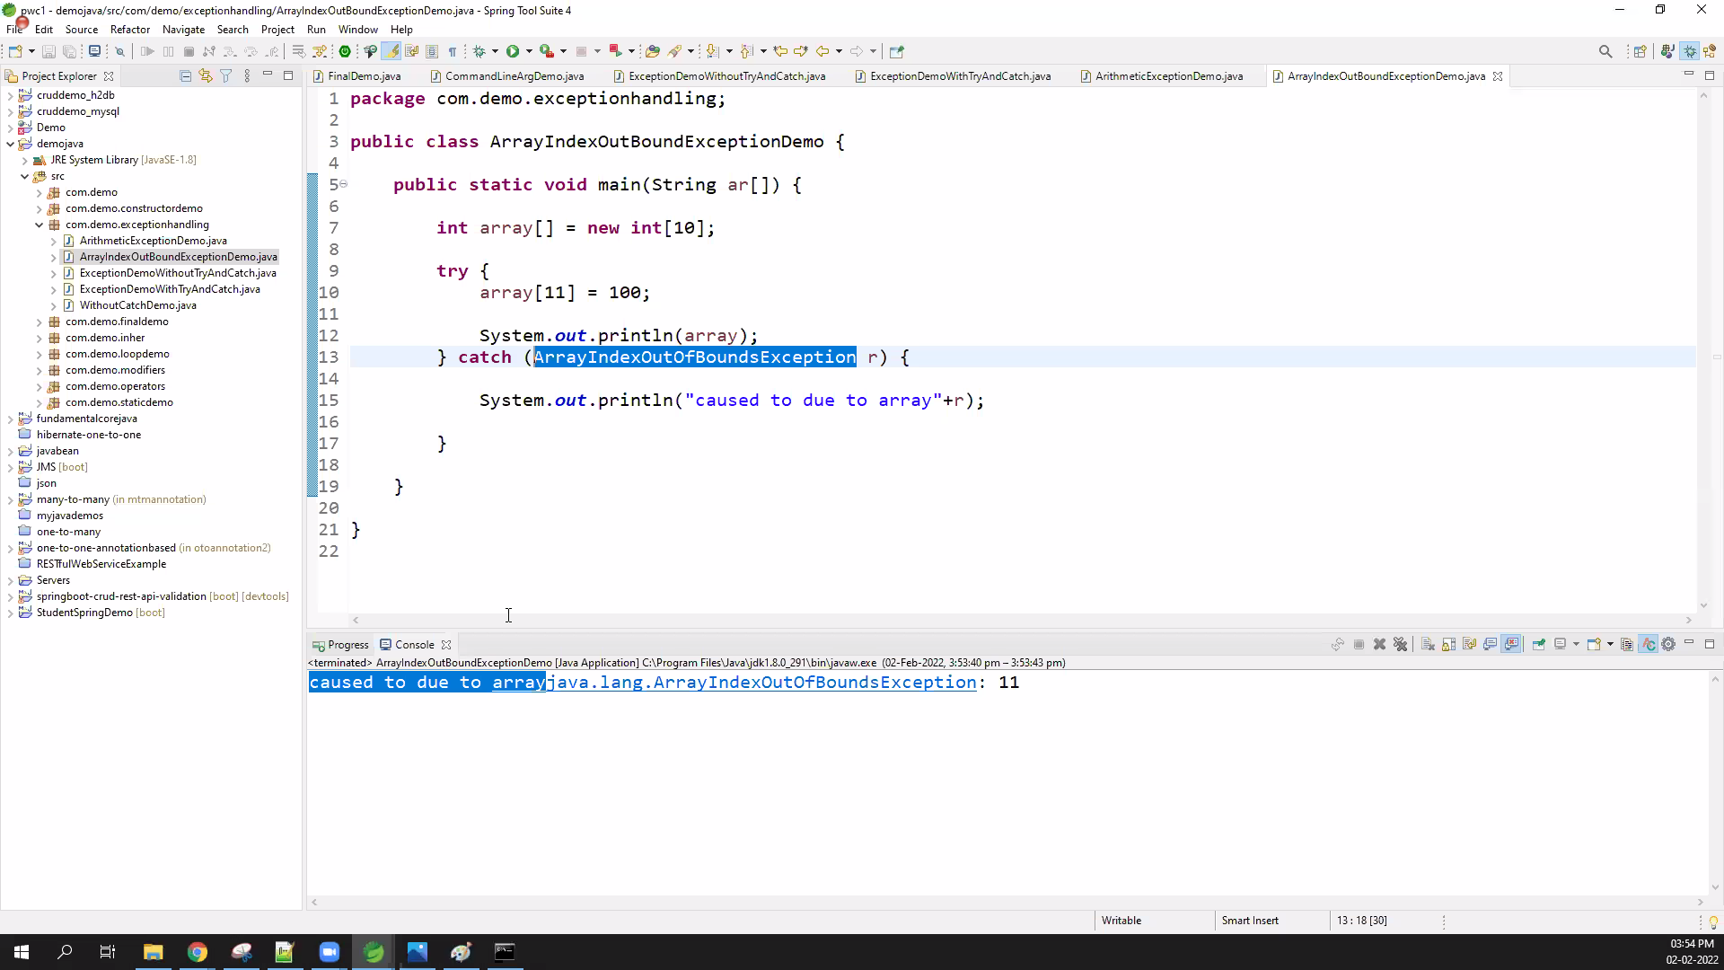

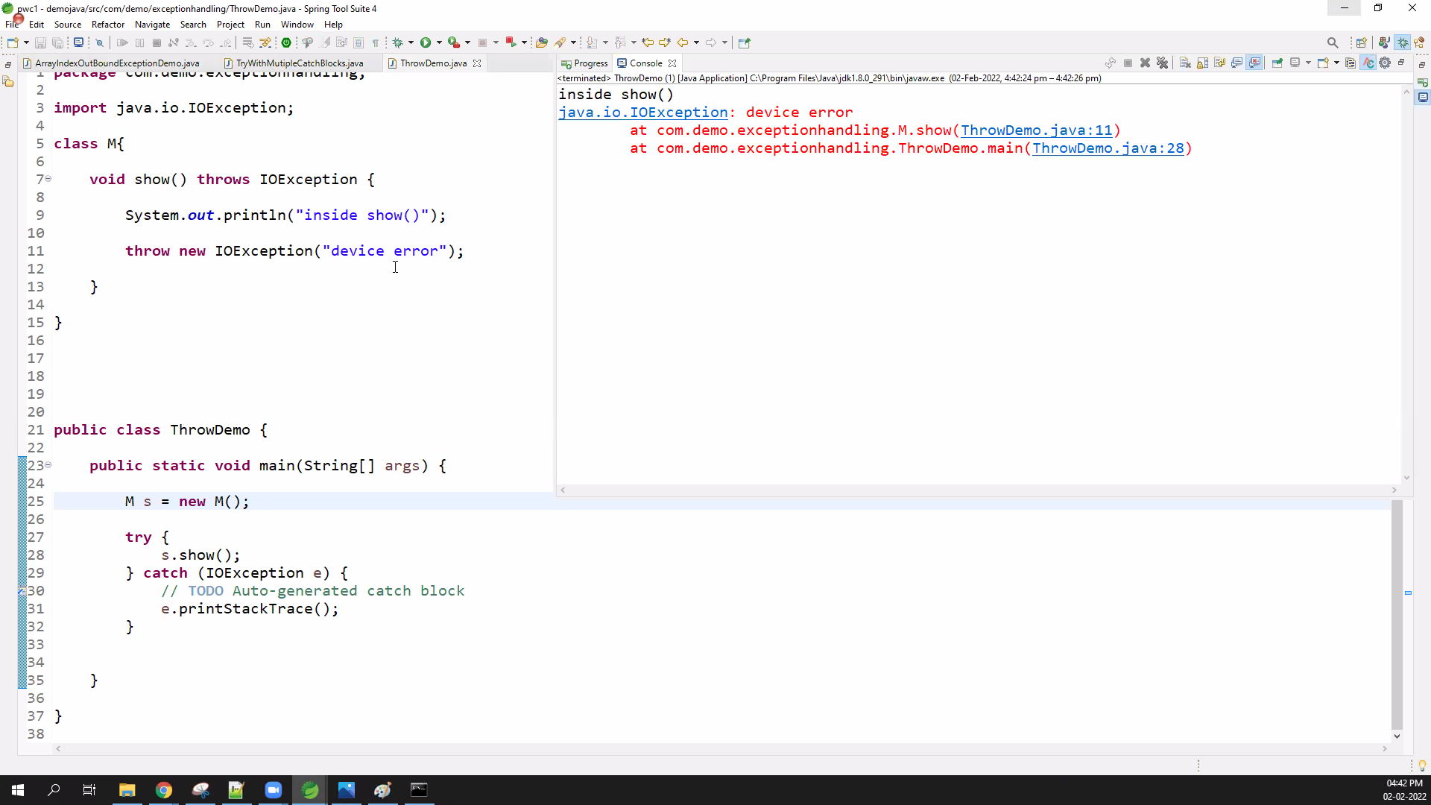

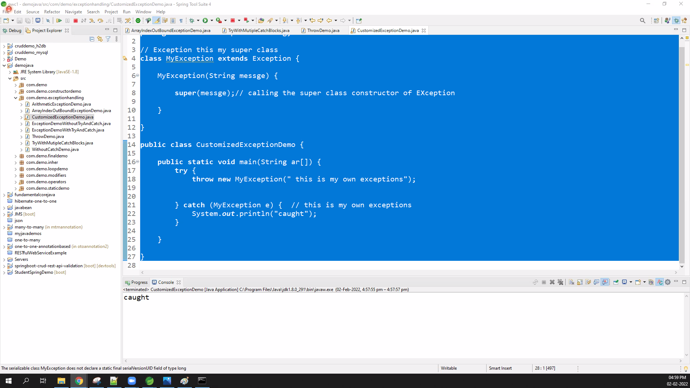

// Exception this my super class

class MyException extends Exception {

MyException(String messge) {

super(messge);// calling the super class constructor of EXception

}

}

public class CustomizedExceptionDemo {

public static void main(String ar[]) {

try {

throw new MyException(" this is my own exceptions");

} catch (MyException e) { // this is my own exceptions

System.out.println("caught");

}

}

}

<https://www.geeksforgeeks.org/g-fact-32-user-defined-custom-exception-in-java/>

Day 4

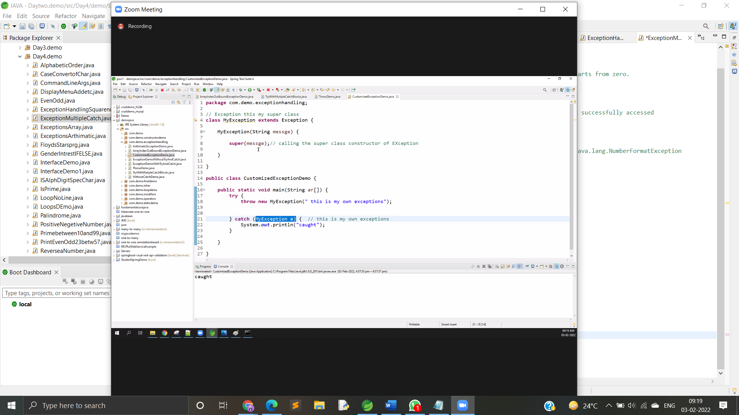

public class NesetedTryDemo {

public static void main(String ar[]) {

try {

/// 1th

try {

System.out.println("going to divide by 0");

int b = 39 / 0;

} catch (ArithmeticException e) {

} // closed here

//2and

try {

} catch (ArrayIndexOutOfBoundsException e) {

} // closed here

} catch (Exception e) {

System.out.println("handled all exceptions wih trys");

} // closed here

}

}

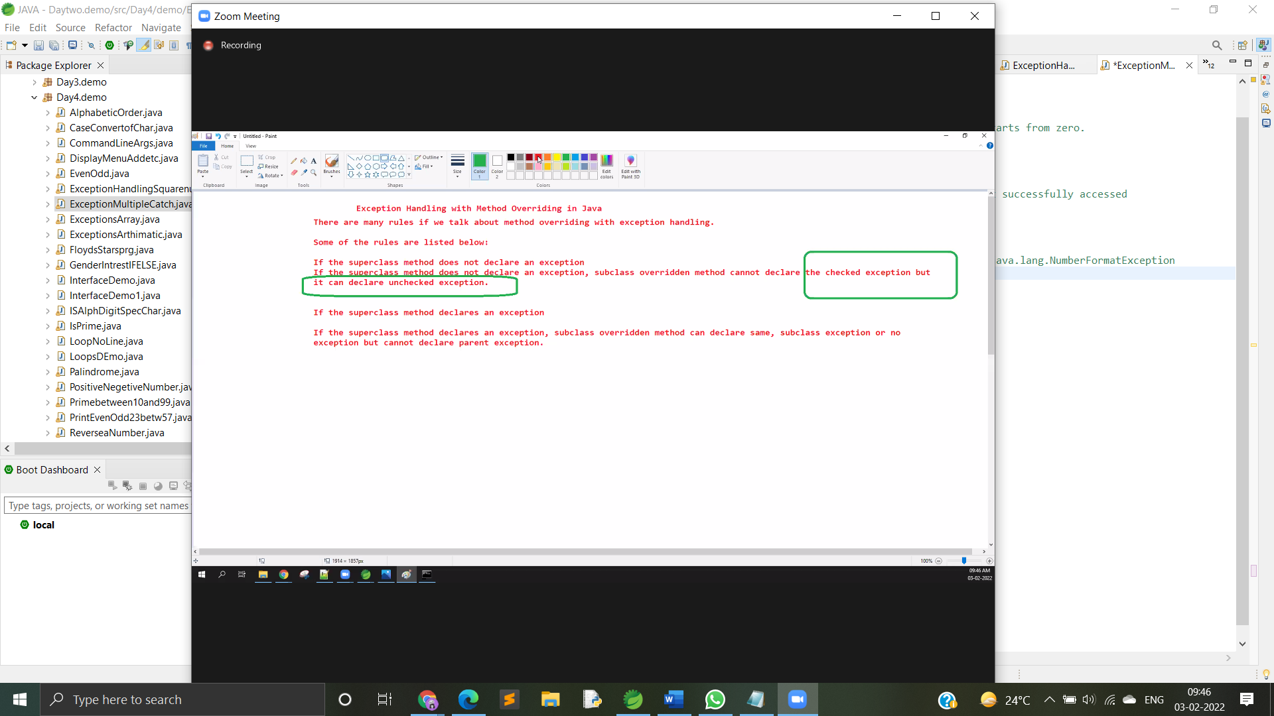

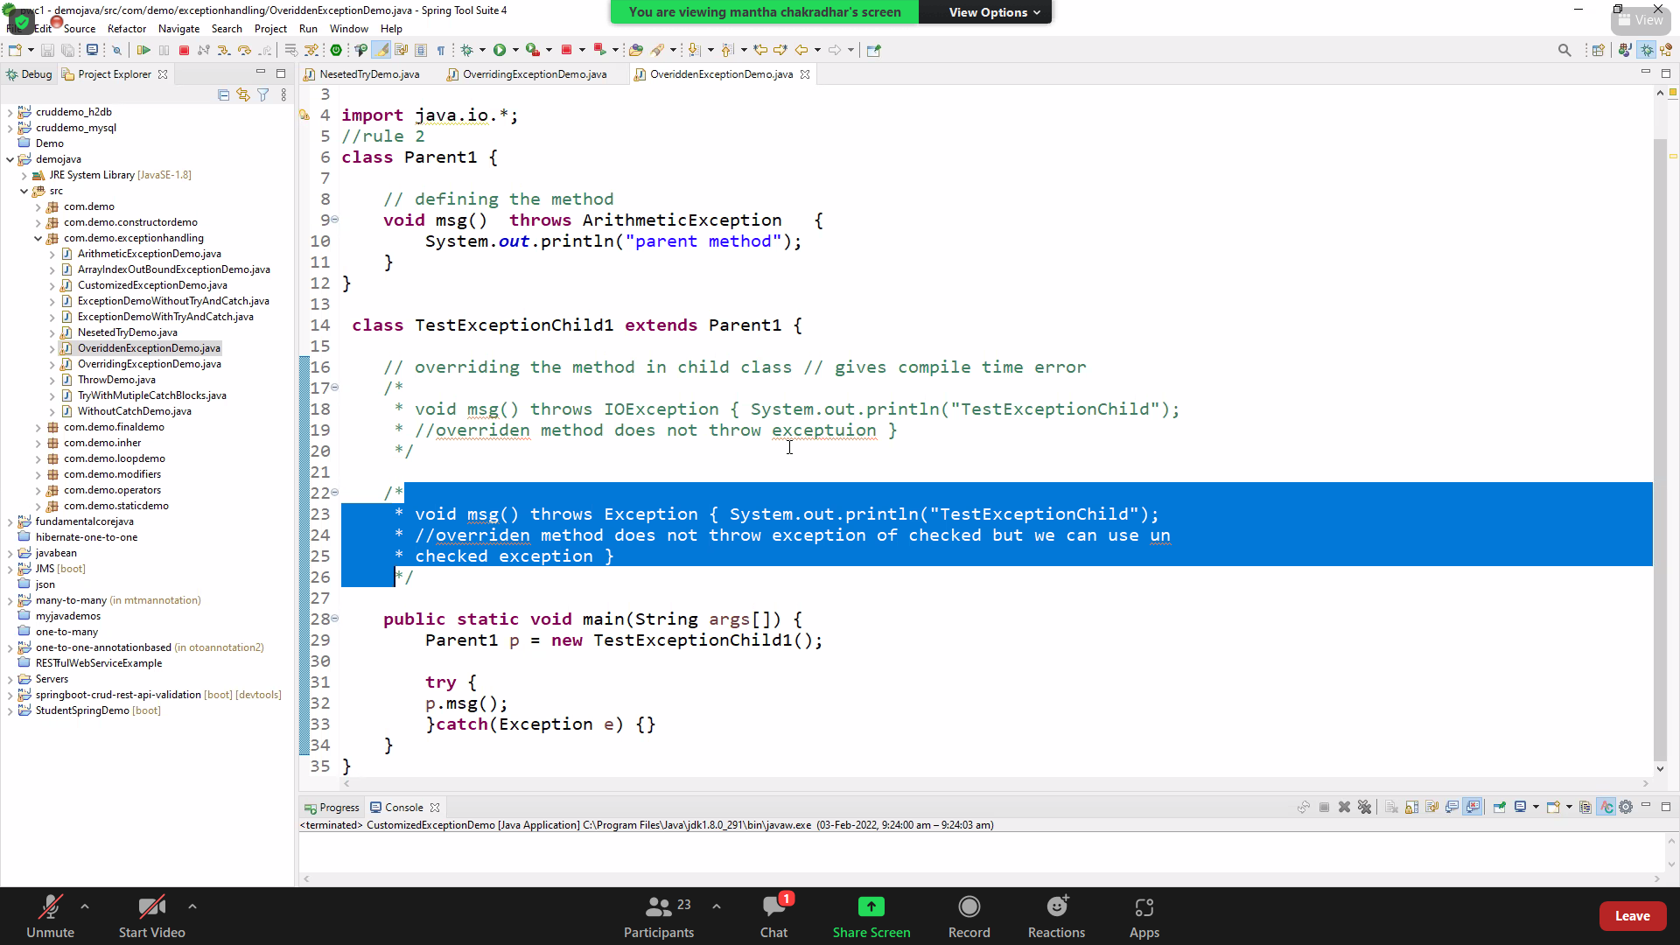

STRINGS

<https://docs.oracle.com/javase/8/docs/api/java/lang/String.html>

string pool

<https://www.journaldev.com/797/what-is-java-string-pool>

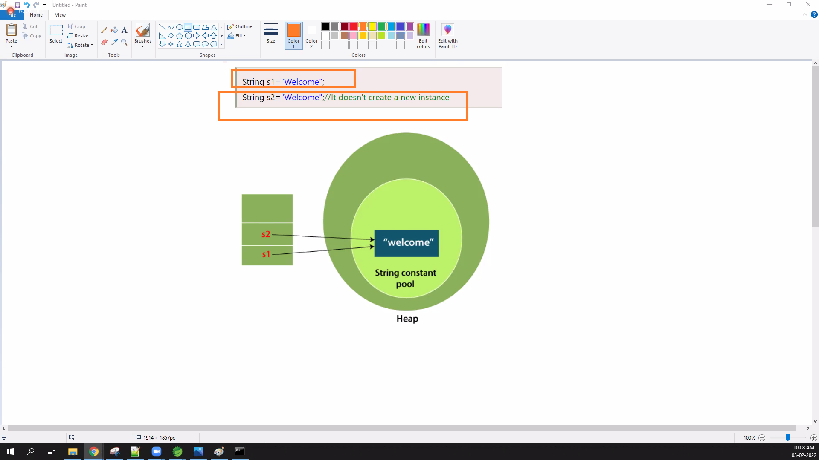

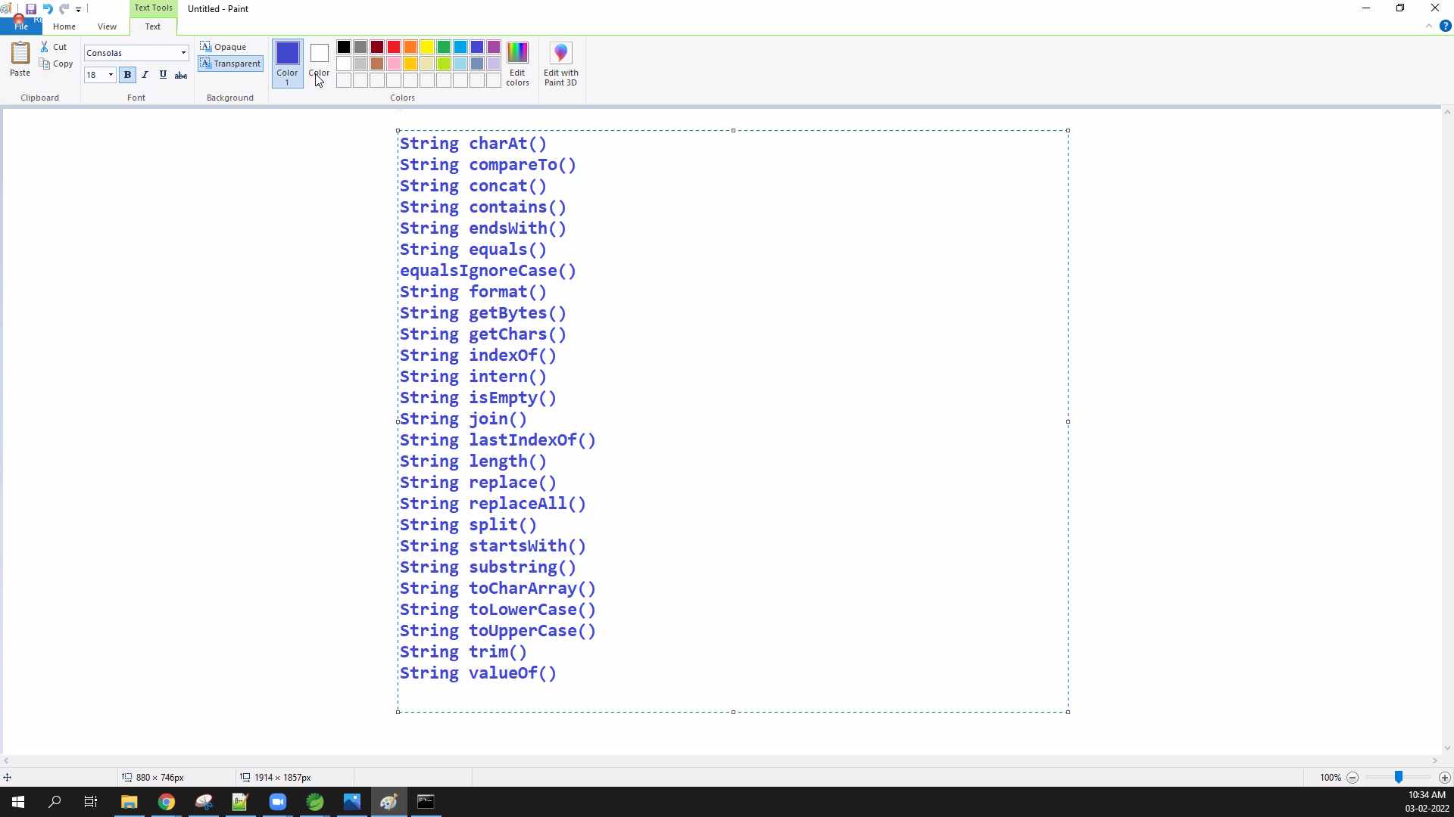

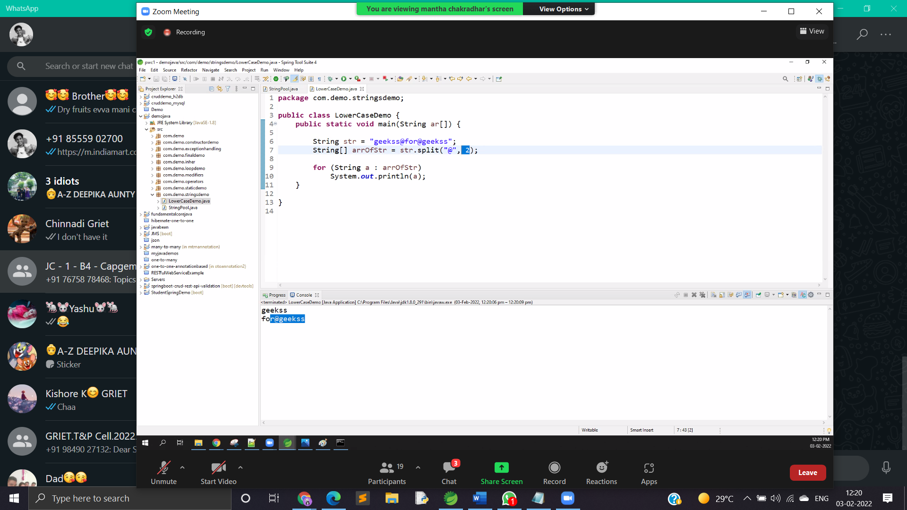

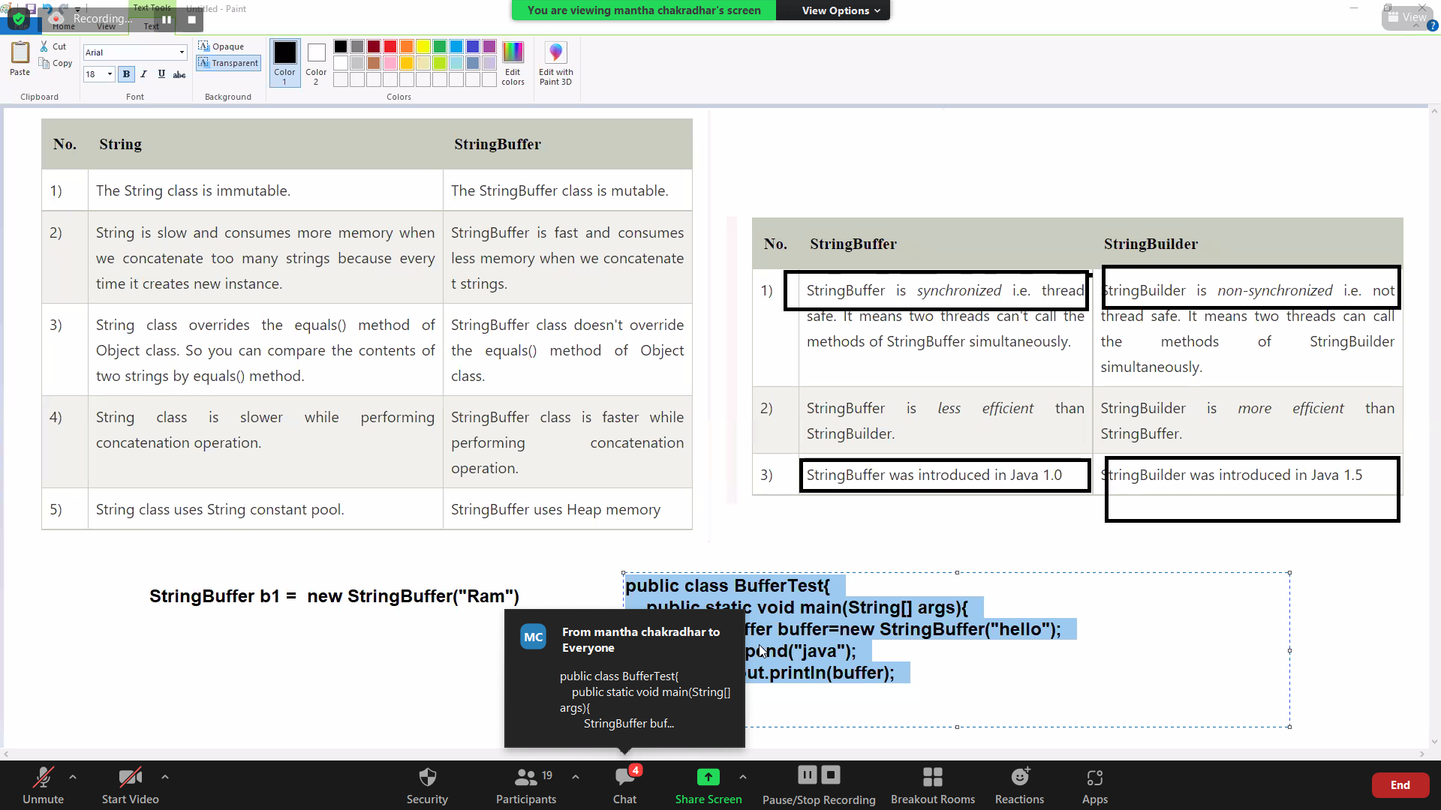

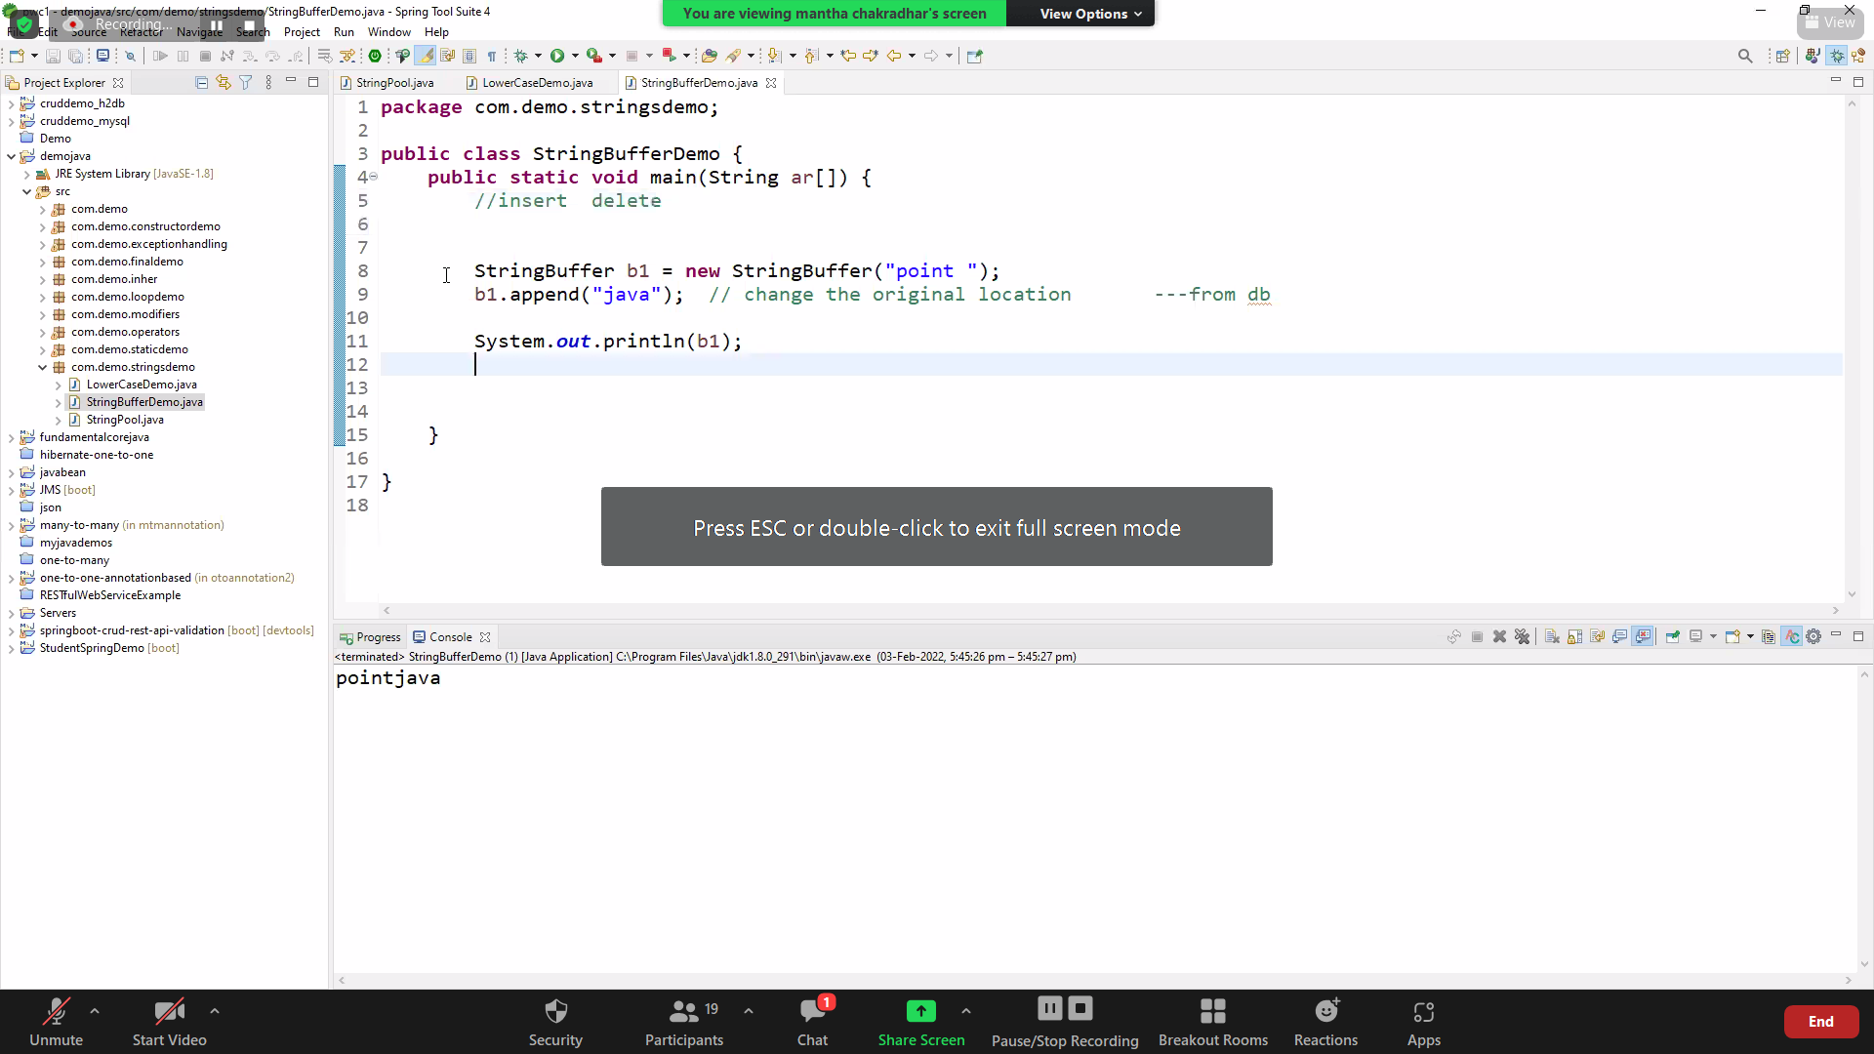

<https://www.javatpoint.com/StringBuffer-class>

<https://www.geeksforgeeks.org/strings-in-java/>

<https://www.w3schools.com/java/java_strings.asp>

public class BufferTest{

public static void main(String[] args){

StringBuffer buffer=new StringBuffer("hello");

buffer.append("java");

System.out.println(buffer);

}

}

String n stringbuffer

Stringbuild n stringbuffer

Difference explained

DAY 6

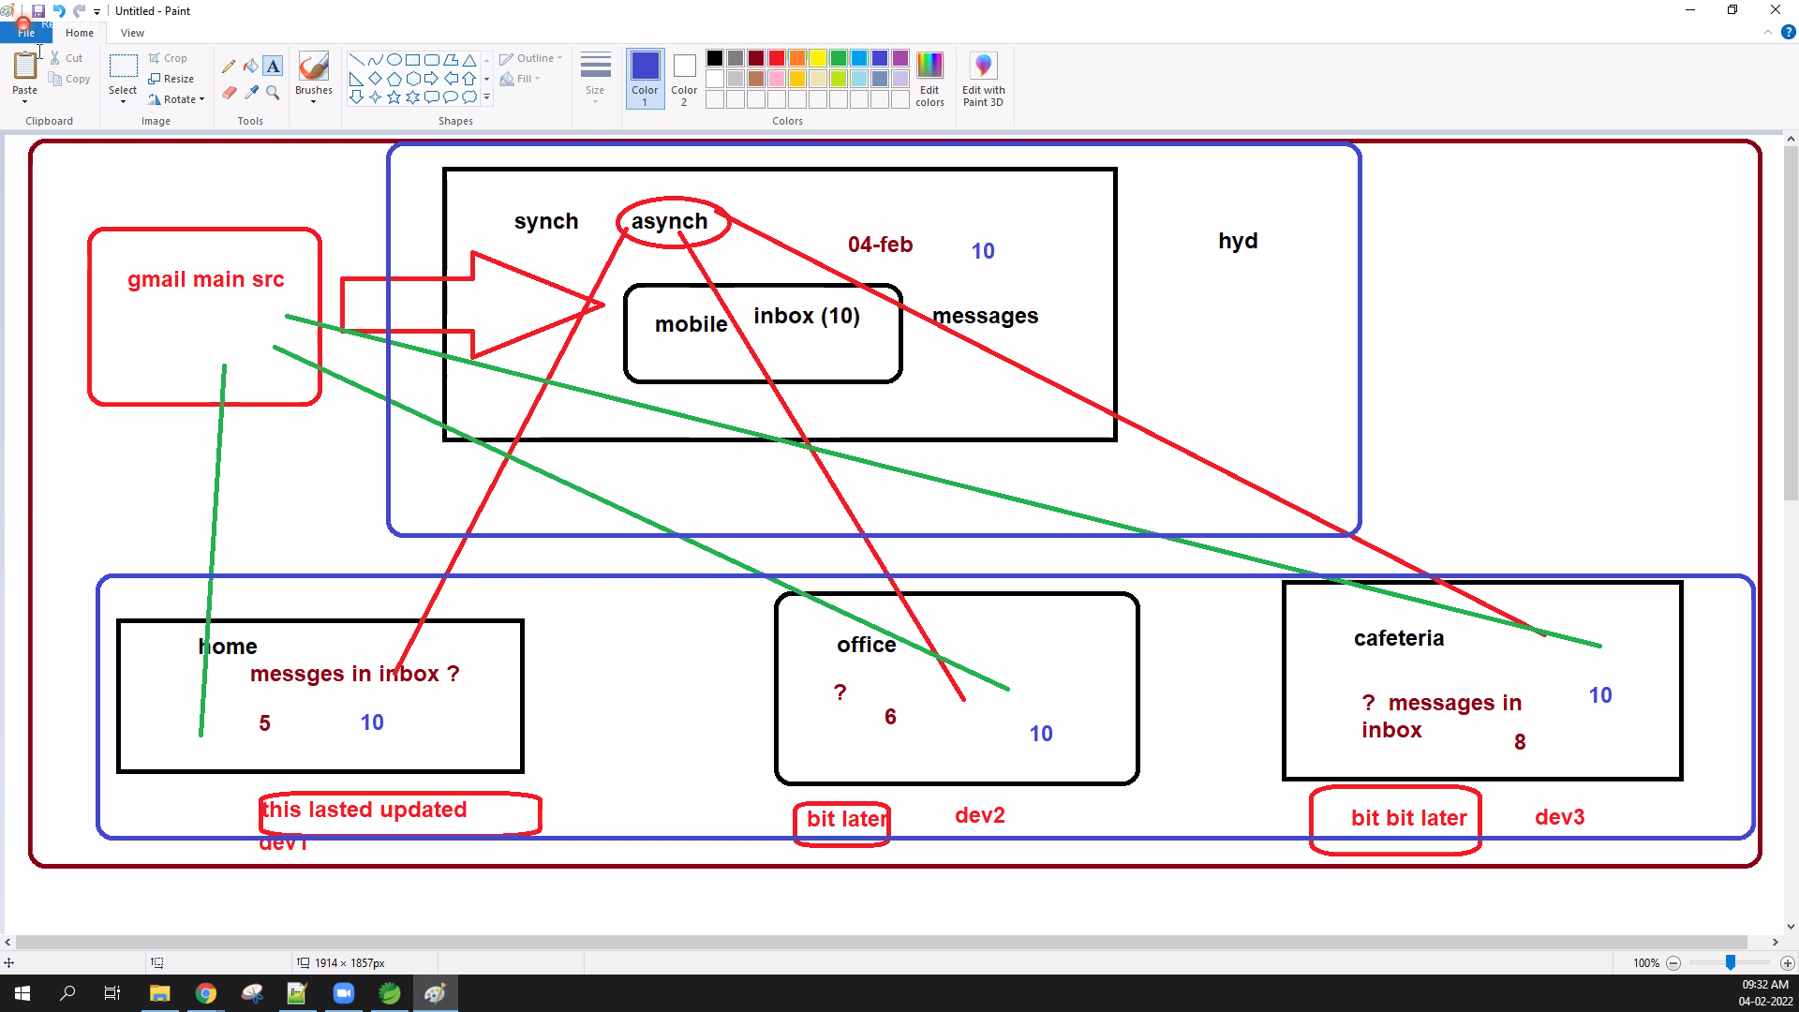

SYNC

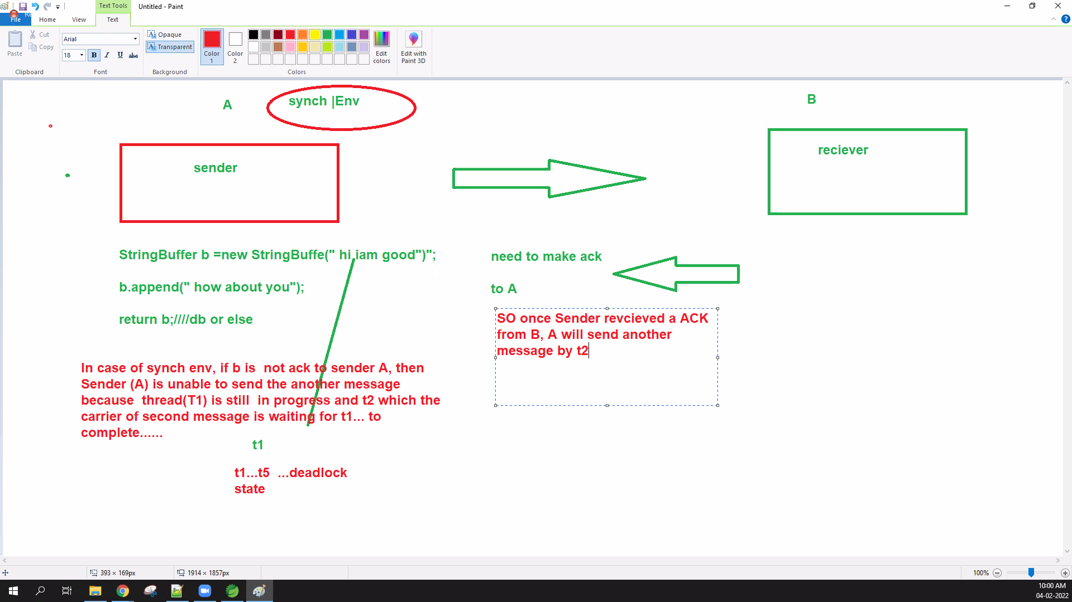

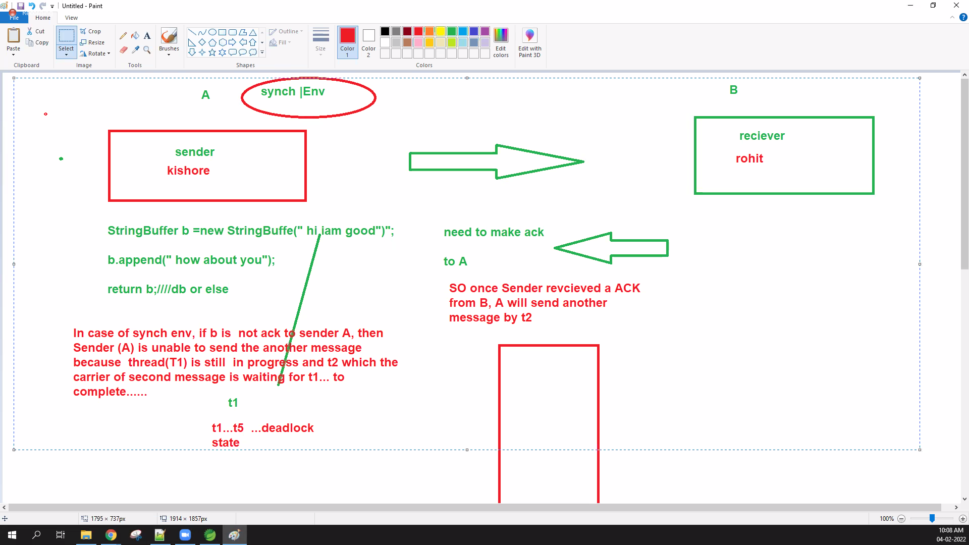

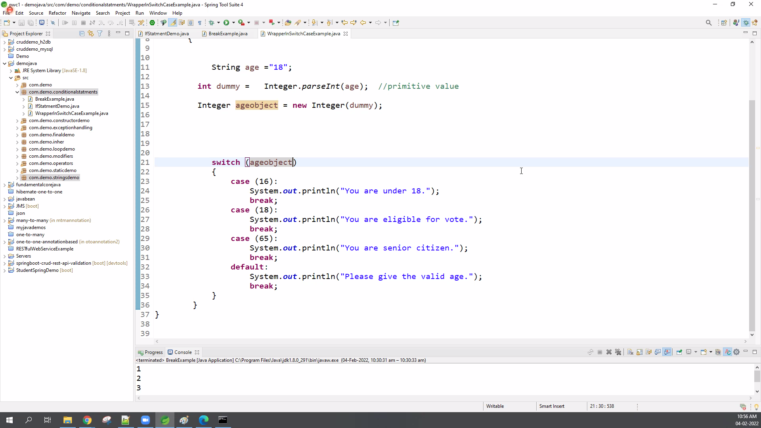

class ThreadDemo1 extends Thread { Thread t; String ThreadName; // constructor ThreadDemo1(String threadname) { ThreadName = threadname; System.out.println("creating " + threadname); } // write logic here public void run() { try { for (int i = 8; i > 0; i--) { System.out.println("Thread " + ThreadName + " ," + i); Thread.sleep(7000);/// this will catch the cpu time of windows os } } catch (InterruptedException e) { System.out.println("thread " + ThreadName + " has been Interrupted"); } } public void start() { System.out.println("thread is starting " + ThreadName); if (t == null) { t = new Thread(this, ThreadName);// new thread created and assign the name to thread class t.start(); } }}public class ThreadDemo {

public static void main(String ar[]) {

ThreadDemo1 t1 = new ThreadDemo1(" thread 1");

t1.start();

ThreadDemo1 t2 = new ThreadDemo1(" thread 2");

t2.start();

}

}

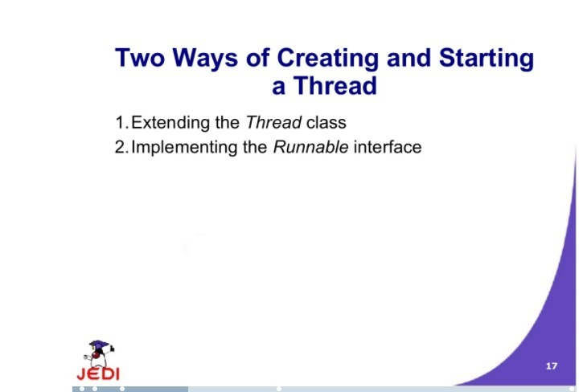

<https://www.slideshare.net/babu4b4u/javathread>

